**CLASS TASK 1:**

**CODE:**

public class ClassTask1 {  
public static void main(String[] args) {  
 int[] numbers = {5, 2, 9, 1, 6};  
 System.*out*.println("Array elements:");  
 for (int i = 0; i < numbers.length; i++) {  
 System.*out*.println("Element at index " + i + ": " + numbers[i]);  
 }  
}  
}

**OUTPUT:**

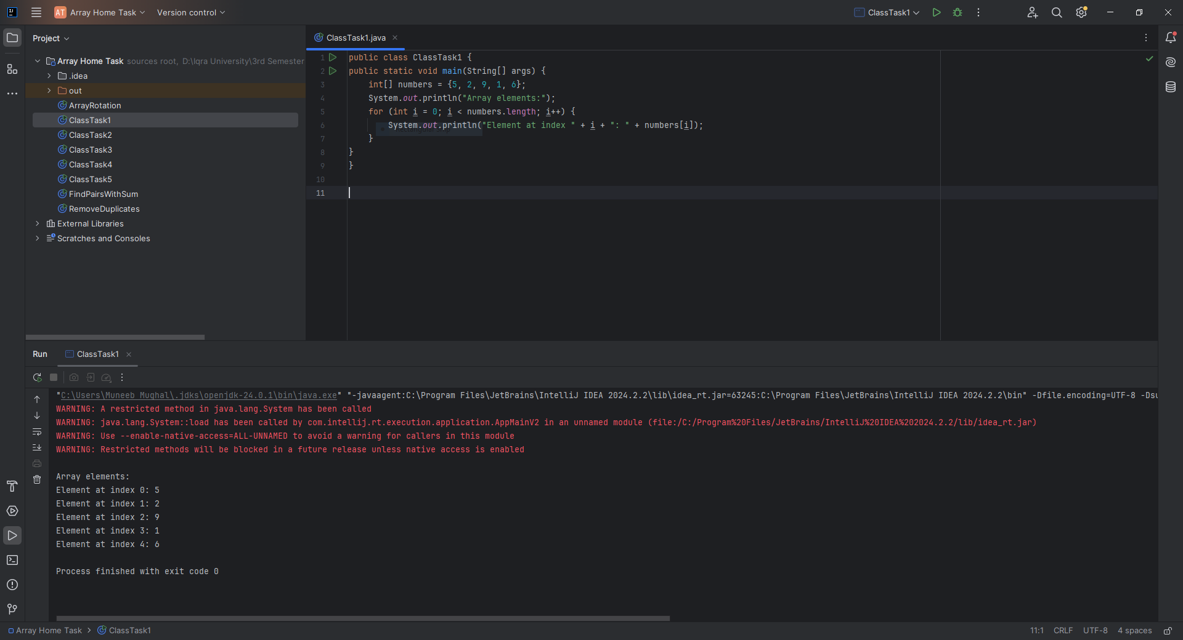

**CLASS TASK 2:**

**CODE:**

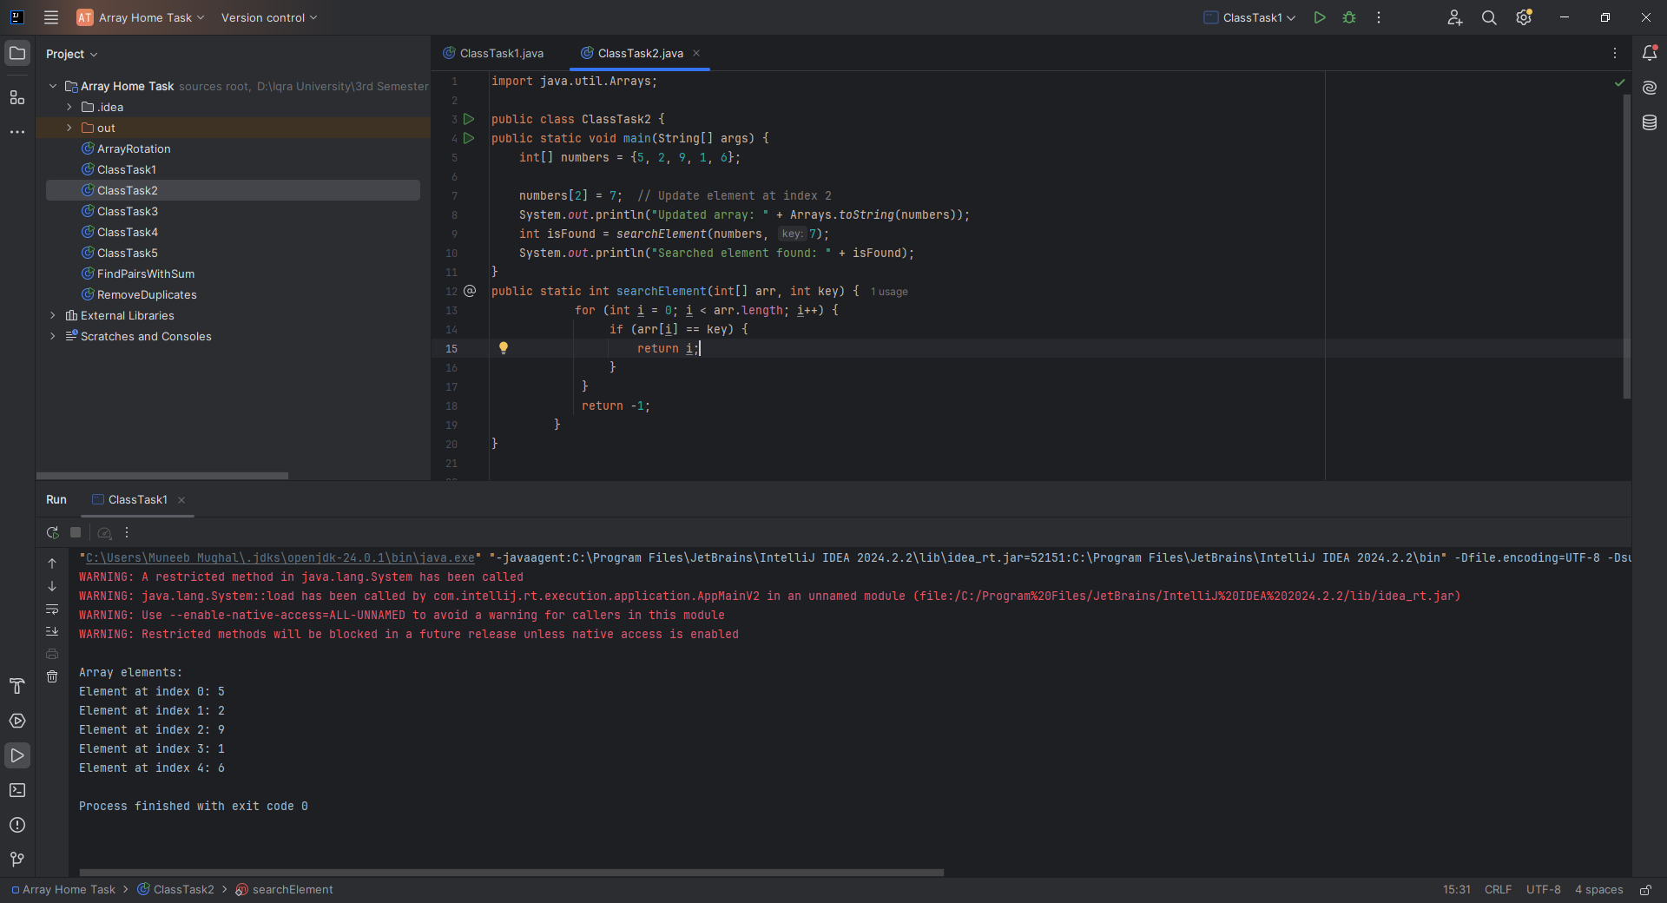import java.util.Arrays;  
  
public class ClassTask2 {  
public static void main(String[] args) {  
 int[] numbers = {5, 2, 9, 1, 6};  
  
 numbers[2] = 7; // Update element at index 2  
 System.*out*.println("Updated array: " + Arrays.*toString*(numbers));  
 int isFound = *searchElement*(numbers, 7);  
 System.*out*.println("Searched element found: " + isFound);  
}  
public static int searchElement(int[] arr, int key) {  
 for (int i = 0; i < arr.length; i++) {  
 if (arr[i] == key) {  
 return i;  
 }  
 }  
 return -1;

}  
}

**CLASS TASK 3:**

**CODE:**

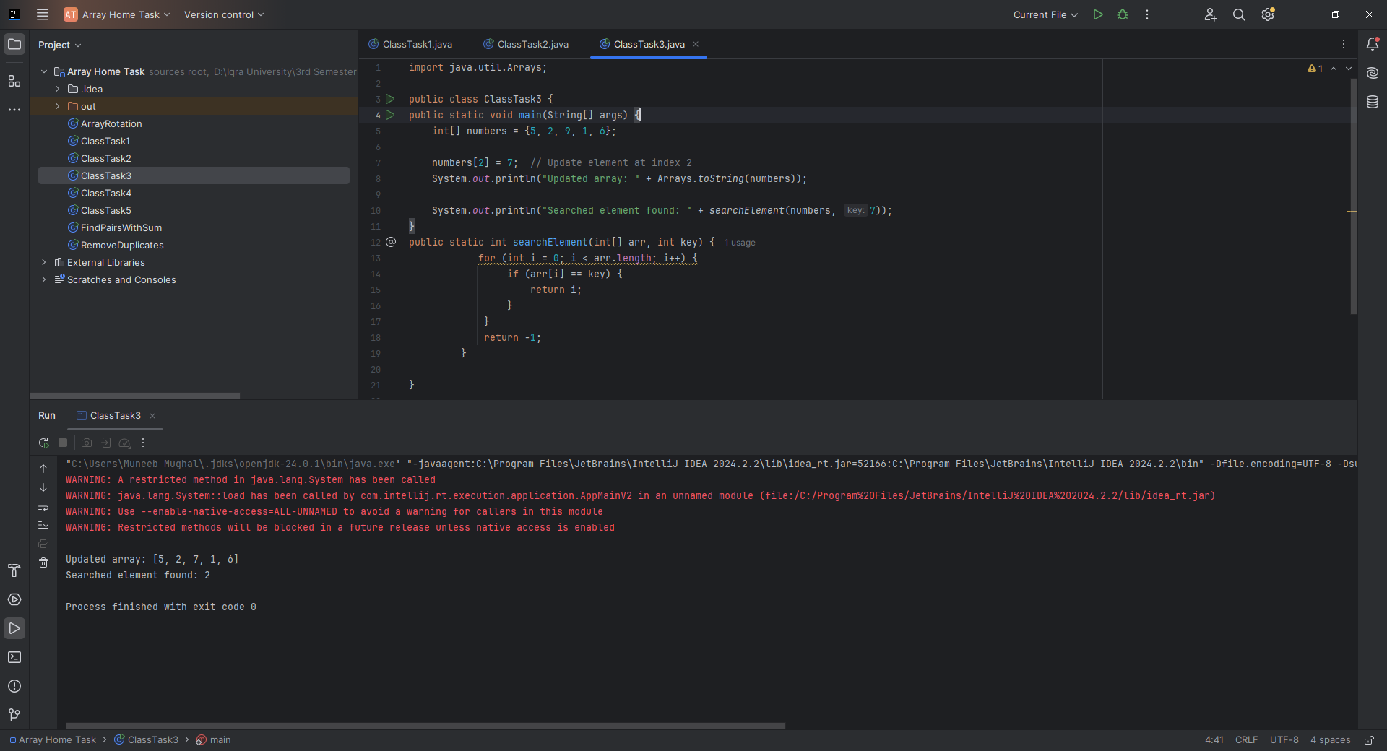import java.util.Arrays;  
  
public class ClassTask3 {  
public static void main(String[] args) {  
 int[] numbers = {5, 2, 9, 1, 6};  
  
 numbers[2] = 7; // Update element at index 2  
 System.*out*.println("Updated array: " + Arrays.*toString*(numbers));  
  
 System.*out*.println("Searched element found: " + *searchElement*(numbers, 7));  
}  
public static int searchElement(int[] arr, int key) {  
 for (int i = 0; i < arr.length; i++) {  
 if (arr[i] == key) {  
 return i;  
 }  
 }  
 return -1;  
 }  
  
}  
**CLASS TASK 4:**

**CODE:**

import java.util.Arrays;  
  
public class ClassTask4 {  
public static void main(String[] args) {  
 int[] numbers = {5, 2, 9, 1, 6};  
  
 System.*out*.println("Max value: " + *findMax*(numbers));  
 System.*out*.println("Find Min: "+ *findMin*(numbers));  
}  
 public static int findMax(int[] arr) {  
 int max = arr[0];  
 for (int i = 1; i < arr.length; i++) {  
 if (arr[i] > max) {  
 max = arr[i];  
 }  
 }  
 return max;  
 }  
 public static int findMin(int[] arr) {  
 int min = arr[0];  
 for (int i = 1; i < arr.length; i++) {  
 if (arr[i] < min) {  
 min = arr[i];  
 }  
 }  
 return min;  
 }  
}

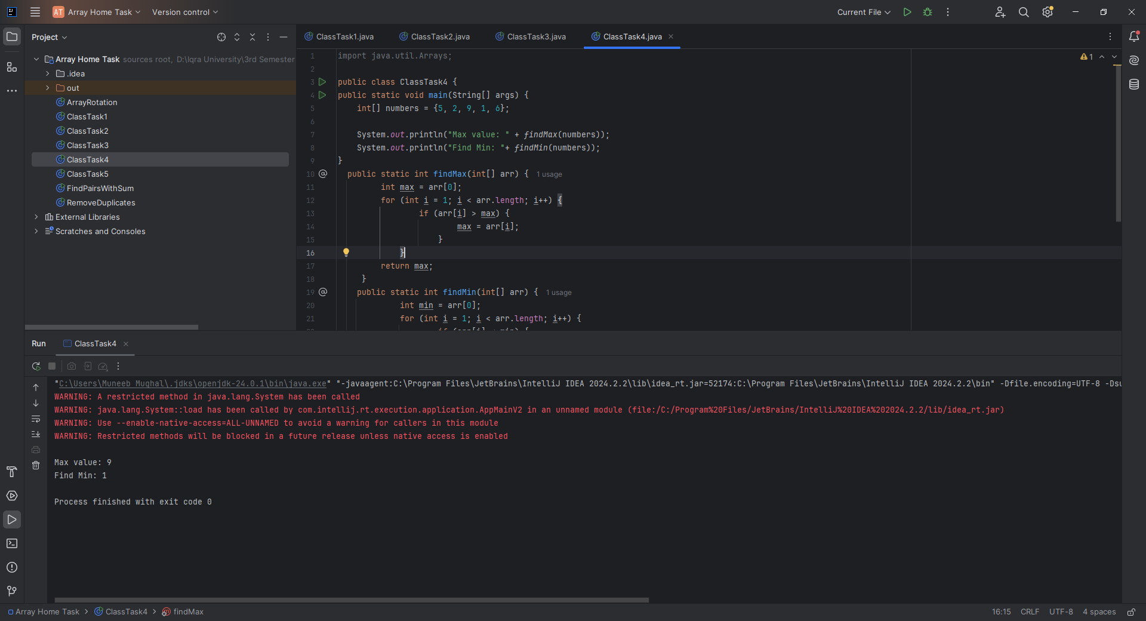

**CLASS TASK 5**

**CODE:**

import java.util.Arrays;  
  
public class ClassTask5 {  
public static void main(String[] args) {  
 int[] grades = {78, 92, 88, 65, 70};  
 Arrays.*sort*(grades);  
 int sum = 0;  
 for (int i = 1; i < grades.length; i++) { // Start from 1 to skip the lowest grade  
 sum += grades[i];  
 }  
 double average = (double) sum / (grades.length - 1);  
 System.*out*.println("Average grade after removing the lowest: " + average);  
  
}  
}

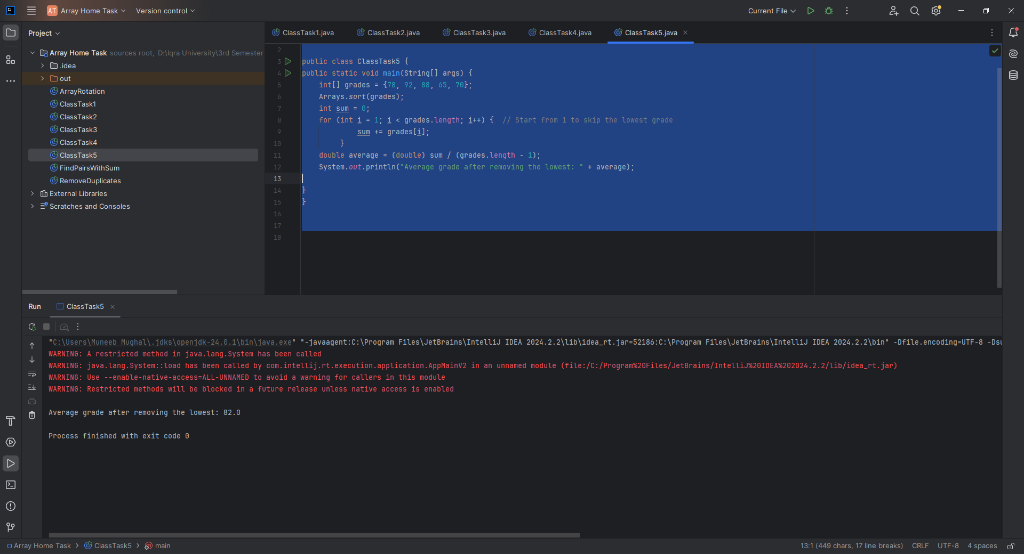

**HOME TASK 1**

**CODE:**

import java.util.Arrays;  
  
public class ArrayRotation {  
 public static int[] rotateArray(int[] arr, int k) {  
 int n = arr.length;  
 k = k % n;  
 int[] result = new int[n];  
  
 for (int i = 0; i < n; i++) {  
 result[(i + k) % n] = arr[i];  
 }  
  
 return result;  
 }  
  
 public static void main(String[] args) {  
 int[] input = {1, 2, 3, 4, 5};  
 int k = 2;  
 int[] output = *rotateArray*(input, k);  
 System.*out*.println("Rotated Array: " + Arrays.*toString*(output));  
 }  
}

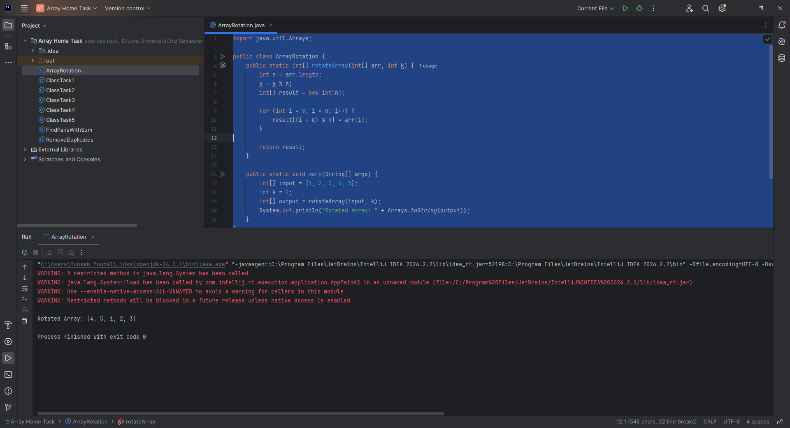

**HOME TASK 2**

**CODE:**public class FindPairsWithSum {  
  
 public static String[] findPairs(int[] arr, int target) {  
 int n = arr.length;  
 String[] tempPairs = new String[n * n]; // max possible size  
 int pairCount = 0;  
  
 for (int i = 0; i < n; i++) {  
 // Check pairs only once  
 for (int j = i + 1; j < n; j++) {  
 if (arr[i] + arr[j] == target) {  
 tempPairs[pairCount++] = "(" + arr[i] + ", " + arr[j] + ")";  
 }  
 }  
 }  
  
 // Copy valid pairs to result array  
 String[] result = new String[pairCount];  
 for (int i = 0; i < pairCount; i++) {  
 result[i] = tempPairs[i];  
 }  
  
 return result;  
 }  
  
 public static void main(String[] args) {  
 int[] input = {1, 2, 3, 4, 5};  
 int target = 6;  
 String[] output = *findPairs*(input, target);  
  
 System.*out*.print("Pairs with sum " + target + ": ");  
 for (String pair : output) {  
 System.*out*.print(pair + " ");  
 }  
 }  
}

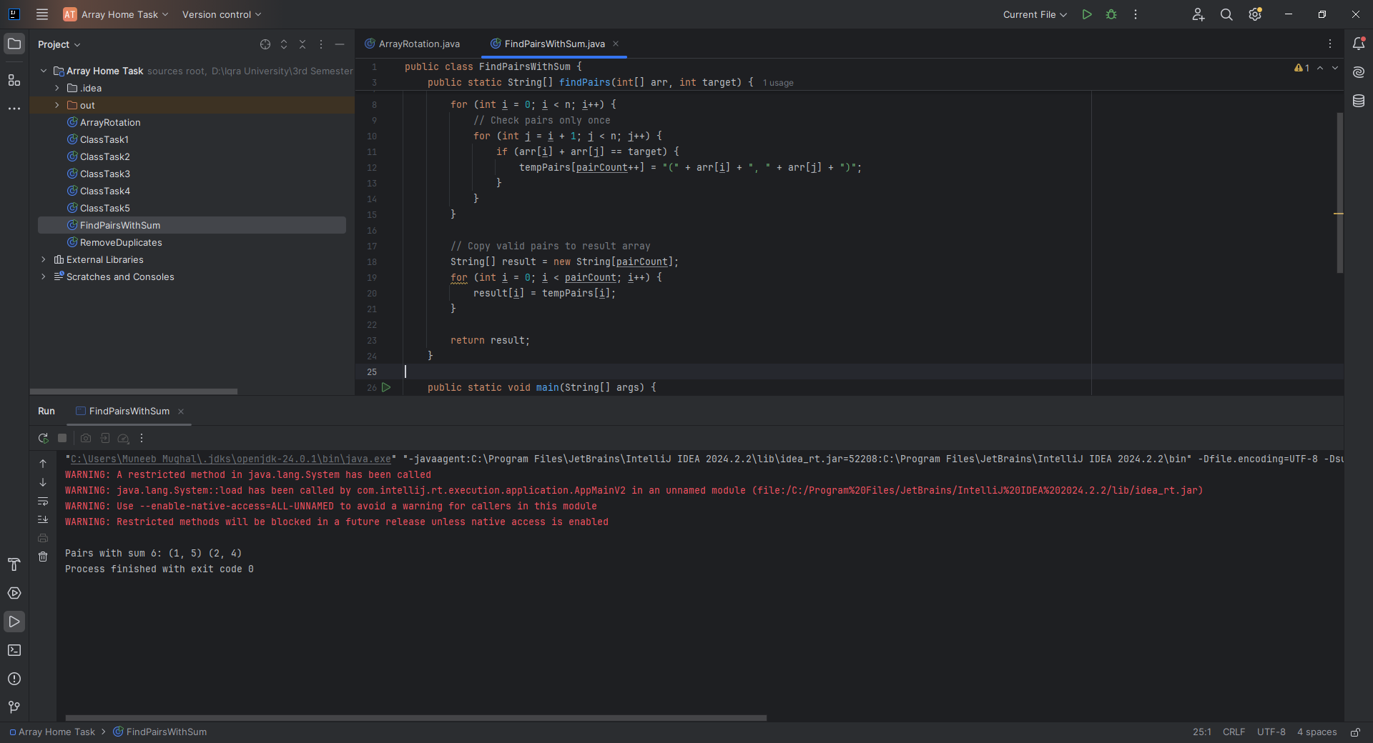

**HOME TASK 3**

**CODE:**

import java.util.Arrays;  
  
public class RemoveDuplicates {  
 public static int[] removeDuplicates(int[] arr) {  
 if (arr.length == 0) return new int[0];  
  
 // First pass: count unique elements  
 int uniqueCount = 1;  
 for (int i = 1; i < arr.length; i++) {  
 if (arr[i] != arr[i - 1]) {  
 uniqueCount++;  
 }  
 }  
  
 // Second pass: store unique elements  
 int[] result = new int[uniqueCount];  
 result[0] = arr[0];  
 int index = 1;  
 for (int i = 1; i < arr.length; i++) {  
 if (arr[i] != arr[i - 1]) {  
 result[index++] = arr[i];  
 }  
 }  
  
 return result;  
 }  
  
 public static void main(String[] args) {  
 int[] input = {1, 2, 2, 3, 4, 4, 5};  
 int[] output = *removeDuplicates*(input);  
 System.*out*.println("Unique Elements: " + Arrays.*toString*(output));  
 }  
}

